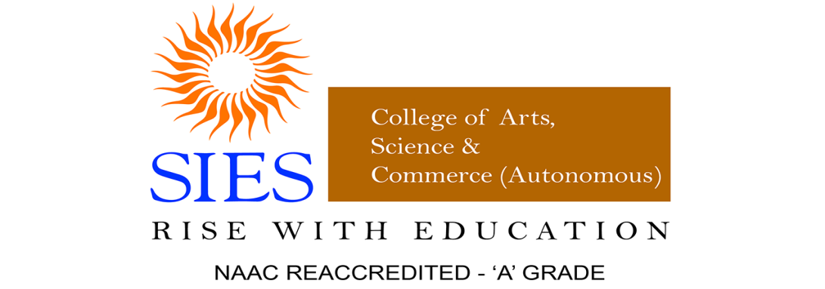
The Department of Mass Media
Seminar Report on Career Guidance Series [Part - 2]
Title of the Session: Opportunities in Advertising Study Abroad
Day & Date and Time: 2nd June 2021, Wednesday, 10:00am-11:30am
Background:
The Department of Mass Media organised a Career Guidance Series for Mass Media Enthusiasts students facilitated by Mr. Hanif Lakdwala.

Seminar Objectives:
- To identify the career opportunities in Advertising Industry
- To know about the career opportunities to study abroad.

Location: Microsoft Teams Learning Management System
Registration done by: 35 prospective TYBAMMC students
Target Audience and Participation: 35 prospective TYBAMMC Students

Session and Name of Resource Person: Online by Dr. Hanif Lakdawala

Details of the Session: The Department of Mass Media organized a Career Guidance Series on 2nd June, 2021 for Advertising aspirants facilitated by Dr.Hanif Lakdwala.
- The interactive session commenced with an introductory talk wherein; Mr. Hanif shared his knowledge and experience in the field of Advertising.
- Dr.Hanif concluded the session with various career opportunities to study in the field of Advertising in India and abroad.

Outcome:
The feedback of participants reflects the following points satisfactorily on:
- To learn the trails involved in the field of Advertising in the glam field
- To understand careers in the field of Advertising in India and abroad

Funding, if any: Nil
Annexures:
- List of Participants:Prospective students of
SYBAMMC 2021-22 who shall seek admission in TY in 2022-23

Meeting Summary
Total Number of Participants | 38
Meeting Title | General
Meeting Start Time | 6/2/2021, 10:24:34 AM
Meeting End Time | 6/2/2021, 11:48:15 AM
Full Name | Join Time | Leave Time | Duration | Email | Role
Vaneeta Raney | 6/2/2021, 10:24:34 AM | 6/2/2021, 11:48:15 AM | 1h 23m | vaneetar@sies.edu.in | Organizer
Hanif Lakdawala | 6/2/2021, 10:25:27 AM | 6/2/2021, 11:48:15 AM | 1h 22m | hanif@ce.sies.edu.in | Presenter
Vanasri Sridhar | 6/2/2021, 10:28:33 AM | 6/2/2021, 11:48:12 AM | 1h 19m | vanasris8500@ascs.sies.edu.in | Attendee
Vaibhavi Bapat | 6/2/2021, 10:28:44 AM | 6/2/2021, 11:48:15 AM | 1h 19m | vaibhavib40948@ascs.sies.edu.in | Attendee
Smrithi Arun | 6/2/2021, 10:30:06 AM | 6/2/2021, 11:48:10 AM | 1h 18m | smrithia22275@ascs.sies.edu.in | Attendee
Shraddha Joshi | 6/2/2021, 10:30:19 AM | 6/2/2021, 11:48:10 AM | 1h 17m | shraddhaj40565@ascs.sies.edu.in | Attendee
Jaanvi Anil Rambade | 6/2/2021, 10:30:29 AM | 6/2/2021, 11:48:12 AM | 1h 17m | jaanvir43426@ascs.sies.edu.in | Attendee
Shubham Dhuri | 6/2/2021, 10:30:57 AM | 6/2/2021, 11:48:07 AM | 1h 17m | shubhamd11921@ascs.sies.edu.in | Attendee
Pujan Rajesh Doshi | 6/2/2021, 10:31:00 AM | 6/2/2021, 11:48:14 AM | 1h 17m | pujand40363@ascs.sies.edu.in | Attendee
bhavikad41514 | 6/2/2021, 10:31:22 AM | 6/2/2021, 11:48:03 AM | 1h 16m | bhavikad41514@ascs.sies.edu.in | Attendee
Aditi Shevade | 6/2/2021, 10:31:24 AM | 6/2/2021, 11:48:14 AM | 1h 16m | aditis14525@ascs.sies.edu.in | Attendee
Pooja laxman Sahu | 6/2/2021, 10:31:35 AM | 6/2/2021, 10:40:27 AM | 8m 52s | poojas40573@ascs.sies.edu.in | Attendee
Pooja laxman Sahu | 6/2/2021, 10:42:44 AM | 6/2/2021, 10:48:05 AM | 5m 21s | poojas40573@ascs.sies.edu.in | Attendee
Pooja laxman Sahu | 6/2/2021, 11:02:18 AM | 6/2/2021, 11:47:50 AM | 45m 32s | poojas40573@ascs.sies.edu.in | Attendee
Arunima Bengeri | 6/2/2021, 10:31:38 AM | 6/2/2021, 11:48:04 AM | 1h 16m | arunimab42499@ascs.sies.edu.in | Attendee
Aaryaa Santhosh Kumar | 6/2/2021, 10:31:53 AM | 6/2/2021, 11:44:03 AM | 1h 12m | aaryaas40129@ascs.sies.edu.in | Attendee
Prajesh Shibu | 6/2/2021, 10:32:02 AM | 6/2/2021, 11:48:08 AM | 1h 16m | prajeshs40705@ascs.sies.edu.in | Attendee
Jason Lopez | 6/2/2021, 10:32:49 AM | 6/2/2021, 11:27:25 AM | 54m 36s | jasonl41421@ascs.sies.edu.in | Attendee
George Fernandes | 6/2/2021, 10:34:01 AM | 6/2/2021, 11:47:58 AM | 1h 13m | georgef43624@ascs.sies.edu.in | Attendee
Janhavi Pathak | 6/2/2021, 10:34:04 AM | 6/2/2021, 11:48:04 AM | 1h 14m | janhavip11577@ascs.sies.edu.in | Attendee
Roshni Selvaraj | 6/2/2021, 10:34:19 AM | 6/2/2021, 11:48:07 AM | 1h 13m | roshnis42020@ascs.sies.edu.in | Attendee
Sakshi Ubale | 6/2/2021, 10:34:22 AM | 6/2/2021, 11:47:59 AM | 1h 13m | sakshiu11415@ascs.sies.edu.in | Attendee
Swarangi sawal | 6/2/2021, 10:34:33 AM | 6/2/2021, 11:48:12 AM | 1h 13m | swarangis43021@ascs.sies.edu.in | Attendee
Isha Thakur | 6/2/2021, 10:35:07 AM | 6/2/2021, 11:48:15 AM | 1h 13m | ishat42824@ascs.sies.edu.in | Attendee
Dhanashree Shreedhar Pai | 6/2/2021, 10:35:26 AM | 6/2/2021, 11:48:04 AM | 1h 12m | dhanashreep40632@ascs.sies.edu.in | Attendee
Radhni Nimbkar | 6/2/2021, 10:35:36 AM | 6/2/2021, 11:48:02 AM | 1h 12m | radhnin40391@ascs.sies.edu.in | Attendee
Hitanshi Kothari | 6/2/2021, 10:35:54 AM | 6/2/2021, 11:48:11 AM | 1h 12m | hitanshik40398@ascs.sies.edu.in | Attendee
Amaan Ansari | 6/2/2021, 10:36:26 AM | 6/2/2021, 11:11:13 AM | 34m 47s | amaana11683@ascs.sies.edu.in | Attendee
Sejal Vishwakarma | 6/2/2021, 10:37:27 AM | 6/2/2021, 11:48:09 AM | 1h 10m | sejalv43103@ascs.sies.edu.in | Attendee
karen passanha | 6/2/2021, 10:41:07 AM | 6/2/2021, 11:48:12 AM | 1h 7m | karen28314@ascs.sies.edu.in | Attendee
esme bangera | 6/2/2021, 10:41:31 AM | 6/2/2021, 11:47:40 AM | 1h 6m | esme8973@ascs.sies.edu.in | Attendee
Kavya Ganapathi | 6/2/2021, 10:41:40 AM | 6/2/2021, 10:44:39 AM | 2m 59s | kavyag12358@ascs.sies.edu.in | Attendee
Kavya Ganapathi | 6/2/2021, 10:52:34 AM | 6/2/2021, 11:09:05 AM | 16m 30s | kavyag12358@ascs.sies.edu.in | Attendee
Hrushikesh Takbhate | 6/2/2021, 10:41:47 AM | 6/2/2021, 11:47:49 AM | 1h 6m | hrushikesht43626@ascs.sies.edu.in | Attendee
Shabbir Khorakiwala | 6/2/2021, 10:42:26 AM | 6/2/2021, 10:43:42 AM | 1m 15s | shabbirk40894@ascs.sies.edu.in | Attendee
Shravani Madhukar Hulavane | 6/2/2021, 10:43:08 AM | 6/2/2021, 11:48:09 AM | 1h 5m | shravanih41388@ascs.sies.edu.in | Attendee
harini lakshman | 6/2/2021, 10:44:53 AM | 6/2/2021, 11:48:05 AM | 1h 3m | harini8942@ascs.sies.edu.in | Attendee
Brahmi Ghadigaonkar | 6/2/2021, 10:51:54 AM | 6/2/2021, 11:47:44 AM | 55m 50s | brahmig42519@ascs.sies.edu.in | Attendee
Yatin Bhatia | 6/2/2021, 10:56:28 AM | 6/2/2021, 11:48:15 AM | 51m 46s | yatinb42435@ascs.sies.edu.in | Attendee
Archana Jaishankar | 6/2/2021, 11:04:29 AM | 6/2/2021, 11:13:54 AM | 9m 24s | archanaj43538@ascs.sies.edu.in | Attendee
Harsh Rane | 6/2/2021, 11:04:49 AM | 6/2/2021, 11:48:15 AM | 43m 25s | harshr41772@ascs.sies.edu.in | Attendee
- Poster

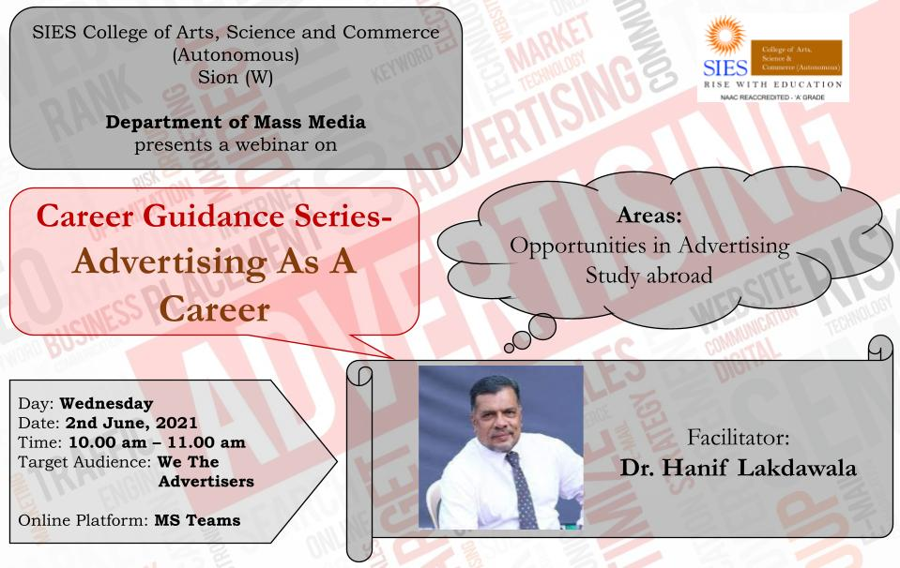

Report Prepared by: Dr. Vaneeta Raney
Course Coordinator,
Department of Mass Media

